EXPERIMENT- 9
1.
# Dataset
inventory <- data.frame(
ProductID = c(1,2,3),
ProductName = c("Product A","Product B","Product C"),
Quantity = c(250,175,300),
Price = c(20,15,18)
)

# Bar Chart
barplot(inventory$Quantity,
names.arg = inventory$ProductName,
col = c("red","green","blue"),
main = "Quantity of Products in Inventory",
xlab = "Products",
ylab = "Quantity Available")
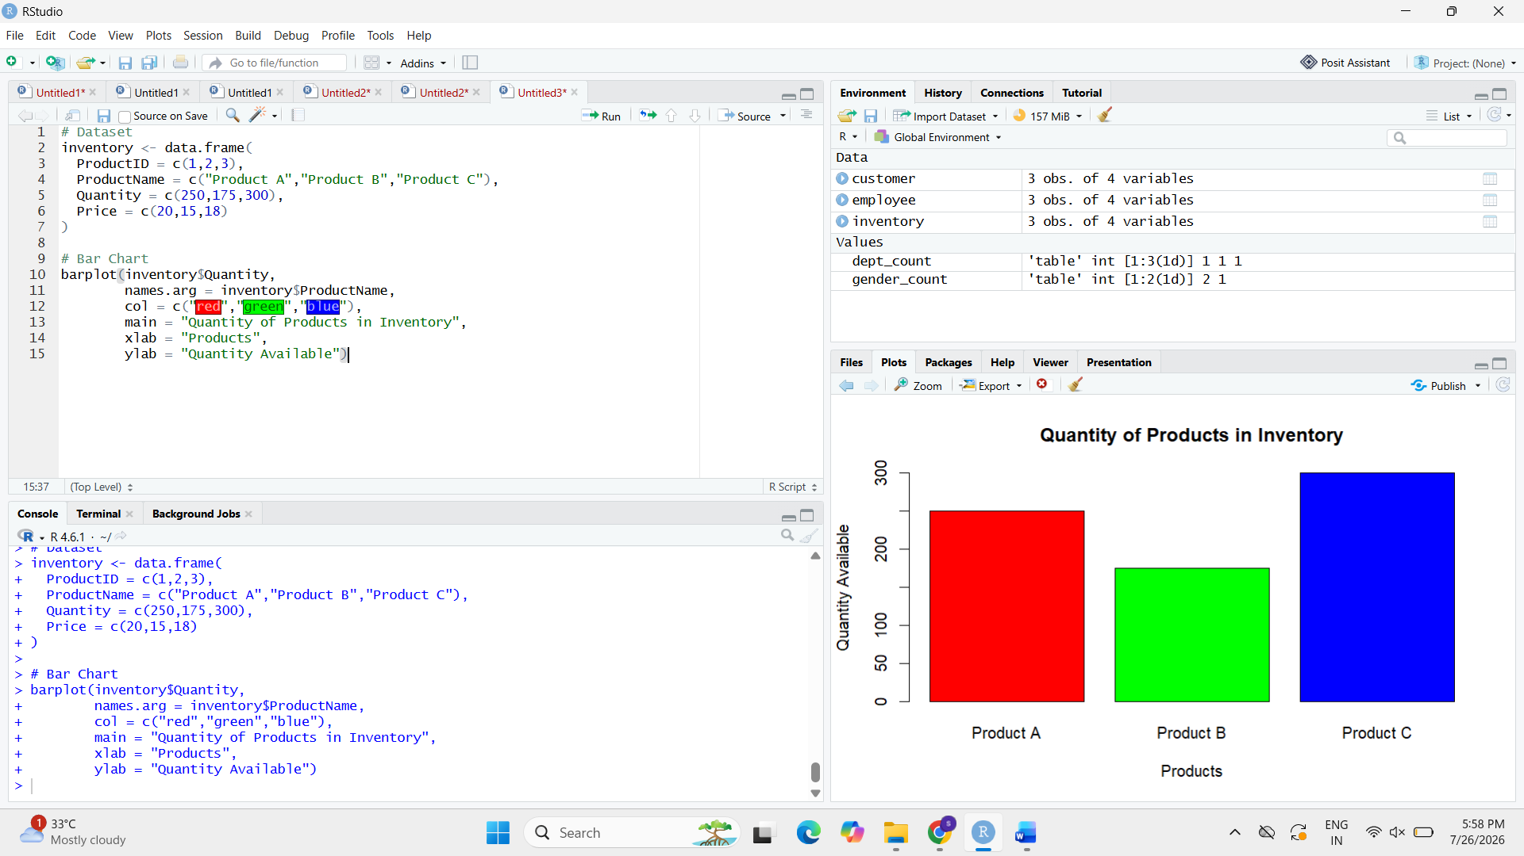
2.
# Dataset
inventory <- data.frame(
ProductName = c("Product A","Product B","Product C"),
Category = c("Category 1","Category 1","Category 2"),
Quantity = c(250,175,300)
)

# Create Matrix
table_data <- xtabs(Quantity ~ Category + ProductName, data = inventory)

# Stacked Bar Chart
barplot(table_data,
col = c("orange","skyblue"),
main = "Quantity by Product Category",
xlab = "Products",
ylab = "Quantity",
legend = rownames(table_data))
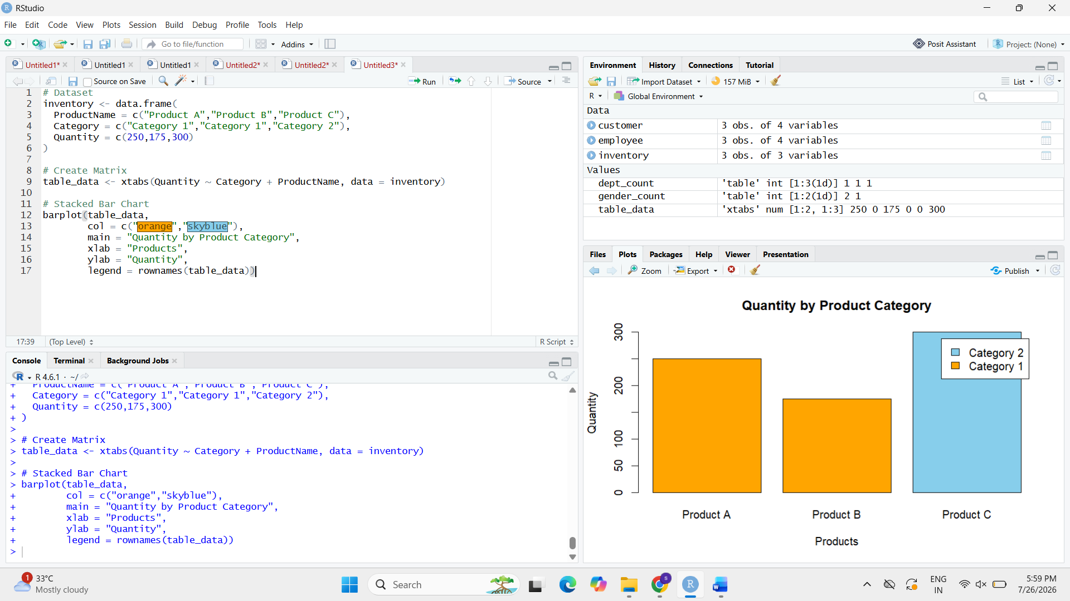
3.
# Dataset
inventory <- data.frame(
ProductID = c(1,2,3),
ProductName = c("Product A","Product B","Product C"),
Quantity = c(250,175,300),
Price = c(20,15,18)
)

# Display Table
print(inventory)
